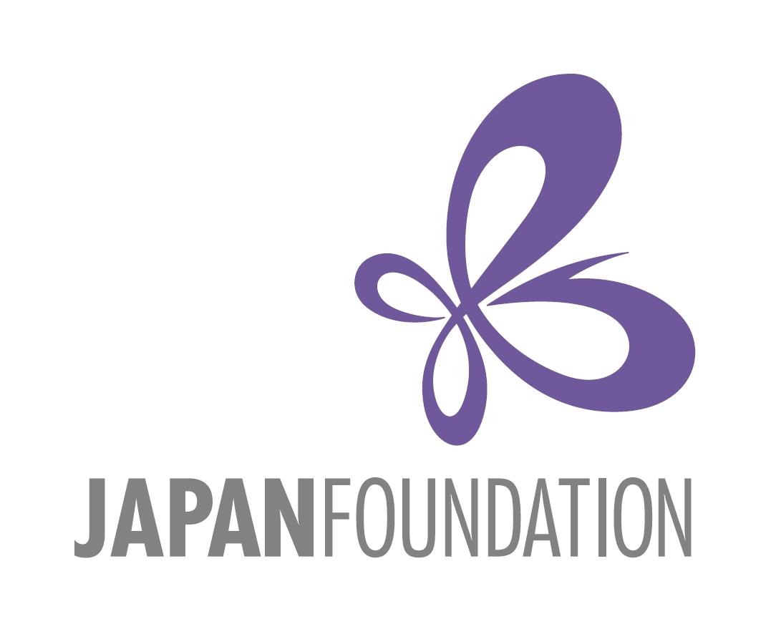

PhD Workshop for Doctoral Students in Japanese Studies in Central and Eastern Europe 2024

Call for Participants

Application Deadline: 4th December, 2023

The Japan Foundation, Budapest (JFBP) would like to invite you to submit an application to participate in the Japanese Study Workshop scheduled for 3-4th February, 2024, in Budapest, Hungary. The official language of the seminar will be English.

The aim of this workshop is to offer a unique opportunity for participants to work together intensively to enhance individual projects and engage in concentrated discussions of common themes and methods. Through presentations and focused sessions, students give and receive critical feedback on thesis projects, fieldwork plans and preliminary results.

The informal environment of the workshop provides doctoral students an opportunity to create a multidisciplinary network of advanced graduate students and senior scholars in Central and Eastern Europe in the field of Japanese Studies.

Through a two-day long intensive workshop, students will be asked to read the work of their peers, comment on the work of each other, and prepare for workshop presentations linking their own work to the broader international Japanese studies field.

We are calling for applications from advanced graduate students who are pursuing PhD degrees in the region. Those who are embarking upon or in the process of writing their PhD dissertations are eligible. Their area of expertise can be in all humanities and social science disciplines (except for Japanese language education), e.g. in politics, history, society, pop culture, literature, arts, language, thought, religion, etc.
About 8 participants will be selected to make an approximately 15-minute long presentation on their research and engage in discussions in English.
Participant students will be supervised by designated senior scholars through the workshop.

§ Eligibility
The following applicants are eligible:
- Full-time graduate students researching fields related to Japanology, regardless of citizenship, who are enrolled at universities in the Central Eastern European region (13 countries, including Bosnia and Herzegovina, Bulgaria, Croatia, Czech, Hungary, Kosovo, North Macedonia , Montenegro, Poland, Romania, Serbia, Slovakia, and Slovenia).
- Students originally from the Central Eastern European region (with nationality of the fore-mentioned 13 countries), who are enrolled in graduate programs outside of the region, but who have a research field related to Japanese Studies.
- Students travelling to the workshop from outside the Central Eastern European region should expect no more than 400 Euro to be paid toward their transportation costs.
- Applications are particularly welcome from graduate students in the early-fieldwork through the middle stages of thesis writing.
- Applicants who participated in JFBP’s PhD workshop or seminar in 2022 and 2021 are eligible if they intend to make different presentations based on their latest research results for this occasion.
- Although the official language of the workshop is English, all applicants are expected to have studied the Japanese language.

§ Application and selection procedures
1. Prior to the workshop, all participants are expected to submit the following as part of their application. All materials should be sent via e-mail to veronika_erdos @jpf.go.jp no later than Monday, 4th December, 2023.

1) A covering letter (no more than one page), indicating the motivation for attending the workshop as well as the current state of progress of doctoral work.
2) A summary of the dissertation project (450-500 words).
3) A brief professional history (CV), including a list of publications, if any.
- One reference letter by a senior scholar of your choice.
2. Applicants will be notified of the selection results by Monday, 11th December, 2023.
3. Following the results of the selection, participants will be requested to submit an essay by Sunday, January 7th, 2024. The essay should be a project outline and progress report of the doctoral research (ca. 1500 words) containing major research questions, structure, sources, methodology, difficulties, if any, etc., or a long essay (3000-3500 words) i.e. any (preliminary) part of the thesis, for example theoretical introduction, research review, data analysis, elaboration of specific questions, and/or arguments etc. The essay should conform to best academic practice (language, referencing, etc.)
This will be edited and compiled afterword for publication, scheduled in 2025.
Senior scholars from the Central and Eastern European region and Japan will be participating and be actively involved in discussions during the workshop. JFBP will seek their advice upon selecting the participants.

§ Travel expenses
JFBP will provide for their transportation (discount economy class air ticket within Europe or 2nd class of train ticket, etc.) to and from Budapest. Accommodations and per diem for participants traveling to Budapest will be provided during the workshop. Details regarding transportation will be provided at a later date.
Participants are expected to have arrived in Budapest on 2nd February and leave on 4th February. The workshop is for a full day on 3rd February and half-day on 4th February.
Students travelling to the workshop from outside the Central Eastern European region should expect no more than 400 Euro to be paid toward their transportation costs.

§ Inquiries
For further information about the workshop or eligibility, please contact Erdős Veronika, Program Assistant, The Japan Foundation, Budapest at to veronika_erdos @jpf.go.jp call +36-1-214-0775.

Thank you for your interest. We look forward to hearing from you!

